**Smart Contract - Sivacoin ICO**

Author: P.Vignesh Siva

Github: https://github.com/siva-492007/blockchain-sivacoin/

# **Sivacoin ICO:**

Initial Coin Offering (ICO) enables customers/investors to buy and sell sivacoins, a cryptocurrency developed by myself using blockchain technology.

# **Creating a smart contract:**

A smart contract is created using solidity which acts as an ICO for Sivacoins. This smart contract is compiled using Remix IDE. This smart contract has the facility to buy, sell sivacoins, how much sivacoin the investor has and how much more sivacoins is available for purchase.

# **Ganache:**

Ganache is an application used to current status of all accounts, including their addresses, private keys, transactions and balances, which can be used for developing and testing purpose. From ganche, we take an account address for our demonstration.

# **MyEthereumWallet:**

MyEthereumWallet is an open source project, which allows to create new ethereum wallet, deploy smart contract and access the deployed smart contract. A new wallet is created using the account address from ganache to make transactions to our smart contract.

# **Equity transactions:**

Whenever an equity of sivacoin is bought/sold, the transaction is added to the blockchain created in ganache.

Buying an equity

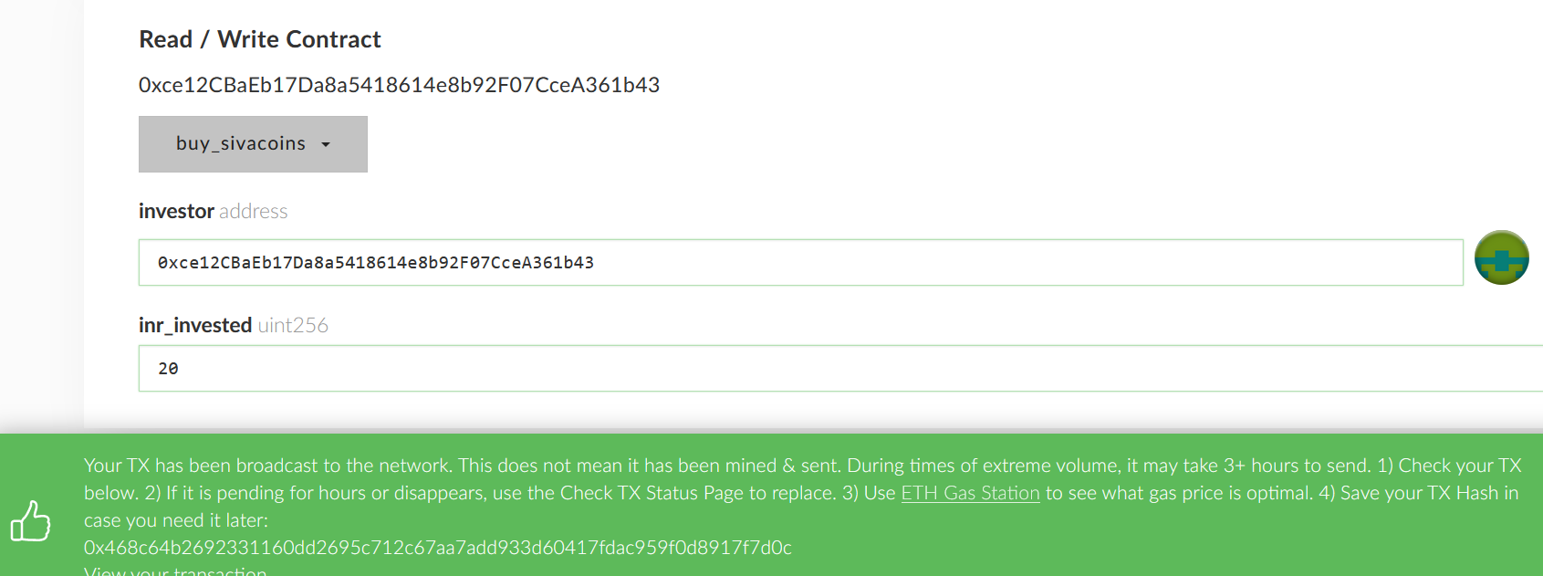

Selling an equity

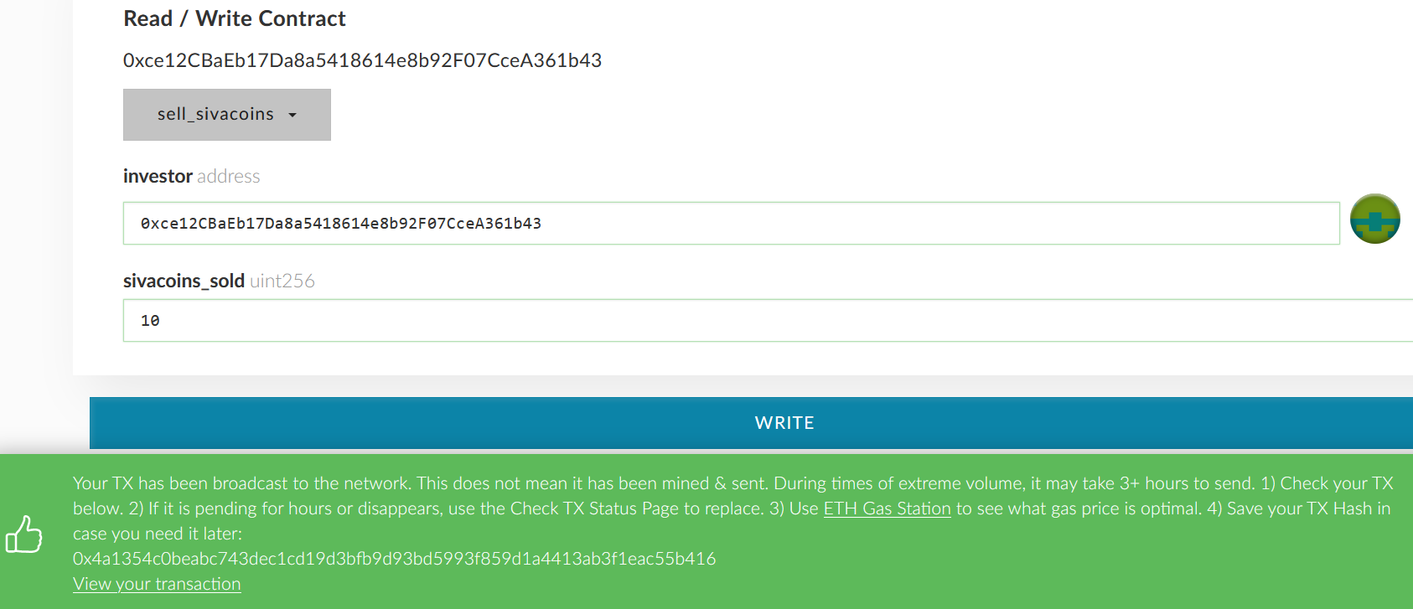

Blockchain containing transactions

